***CENTRAL LIBRARY***

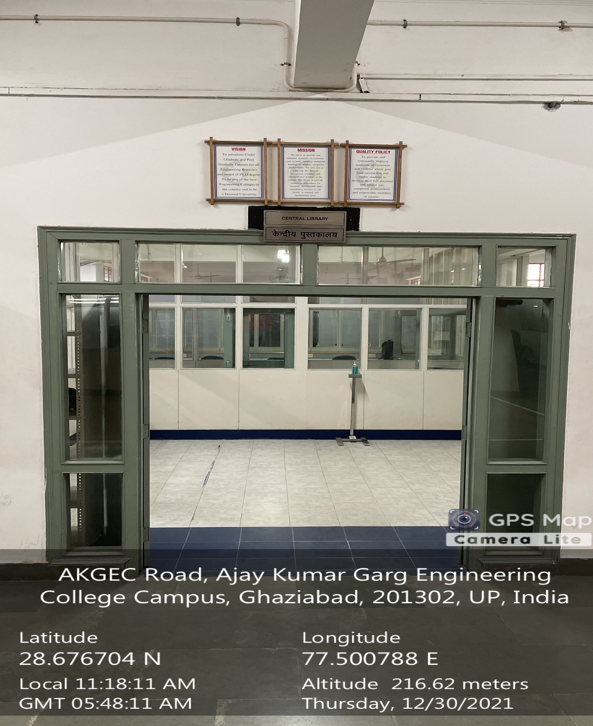

Library Gate

(ADMINISTRATE BLOCK, Ground Floor)

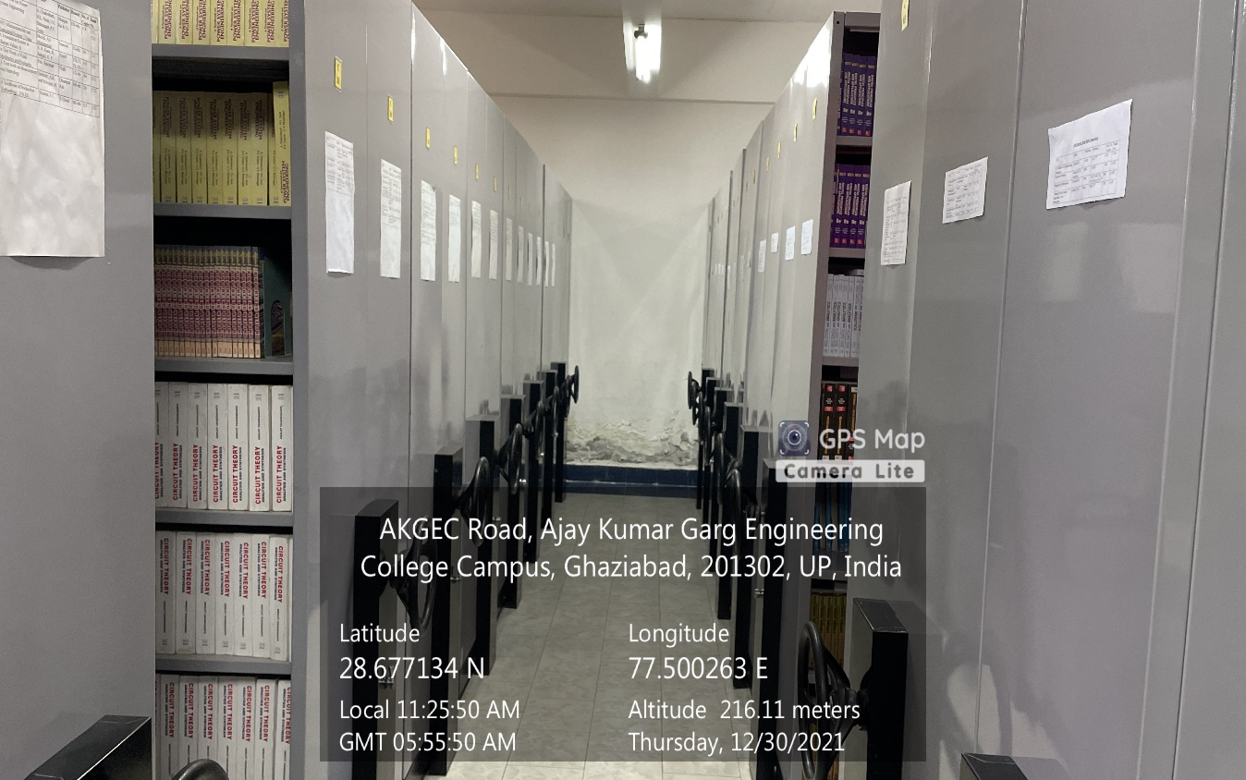

Book Bank

(ADMINISTRATE BLOCK, Ground Floor)

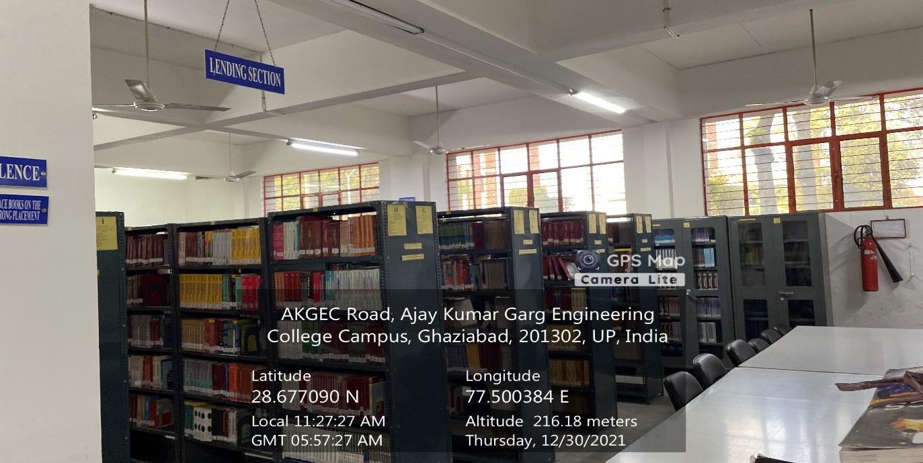

Lending Section

(ADMINISTRATE BLOCK, Ground Floor)

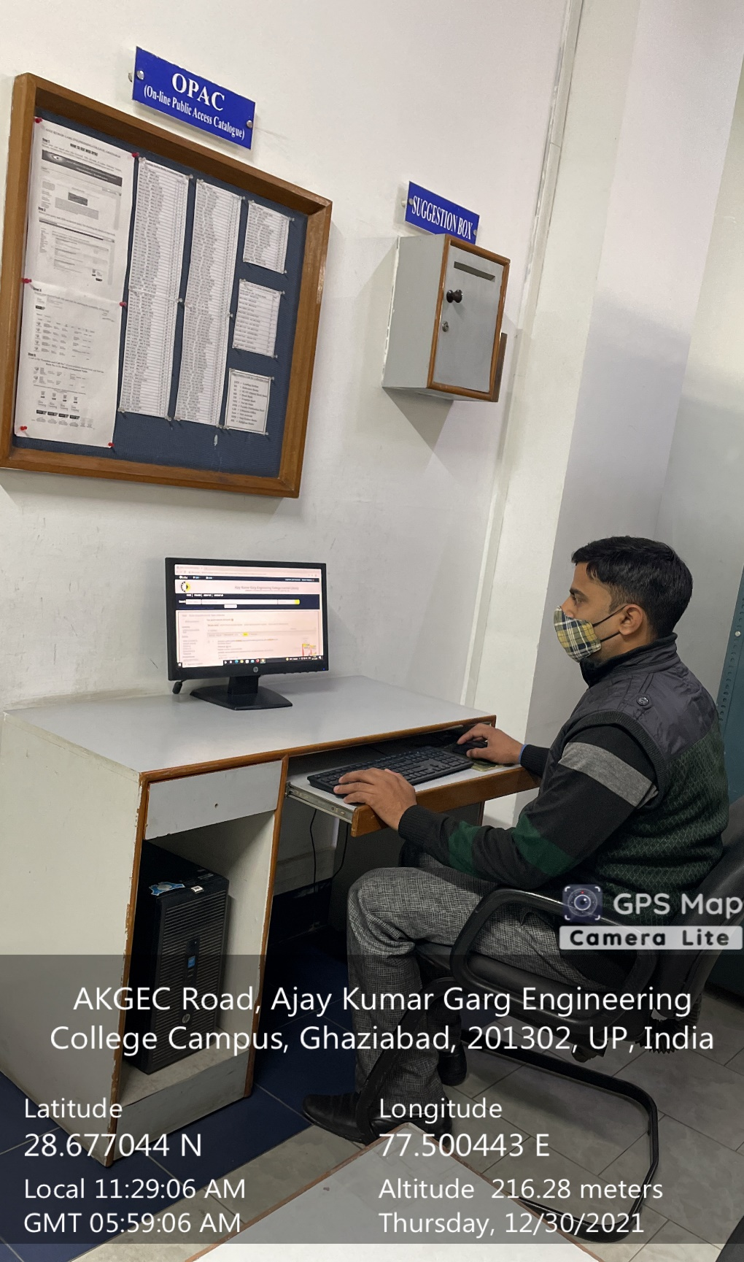

OPAC

(ADMINISTRATE BLOCK, Ground Floor)

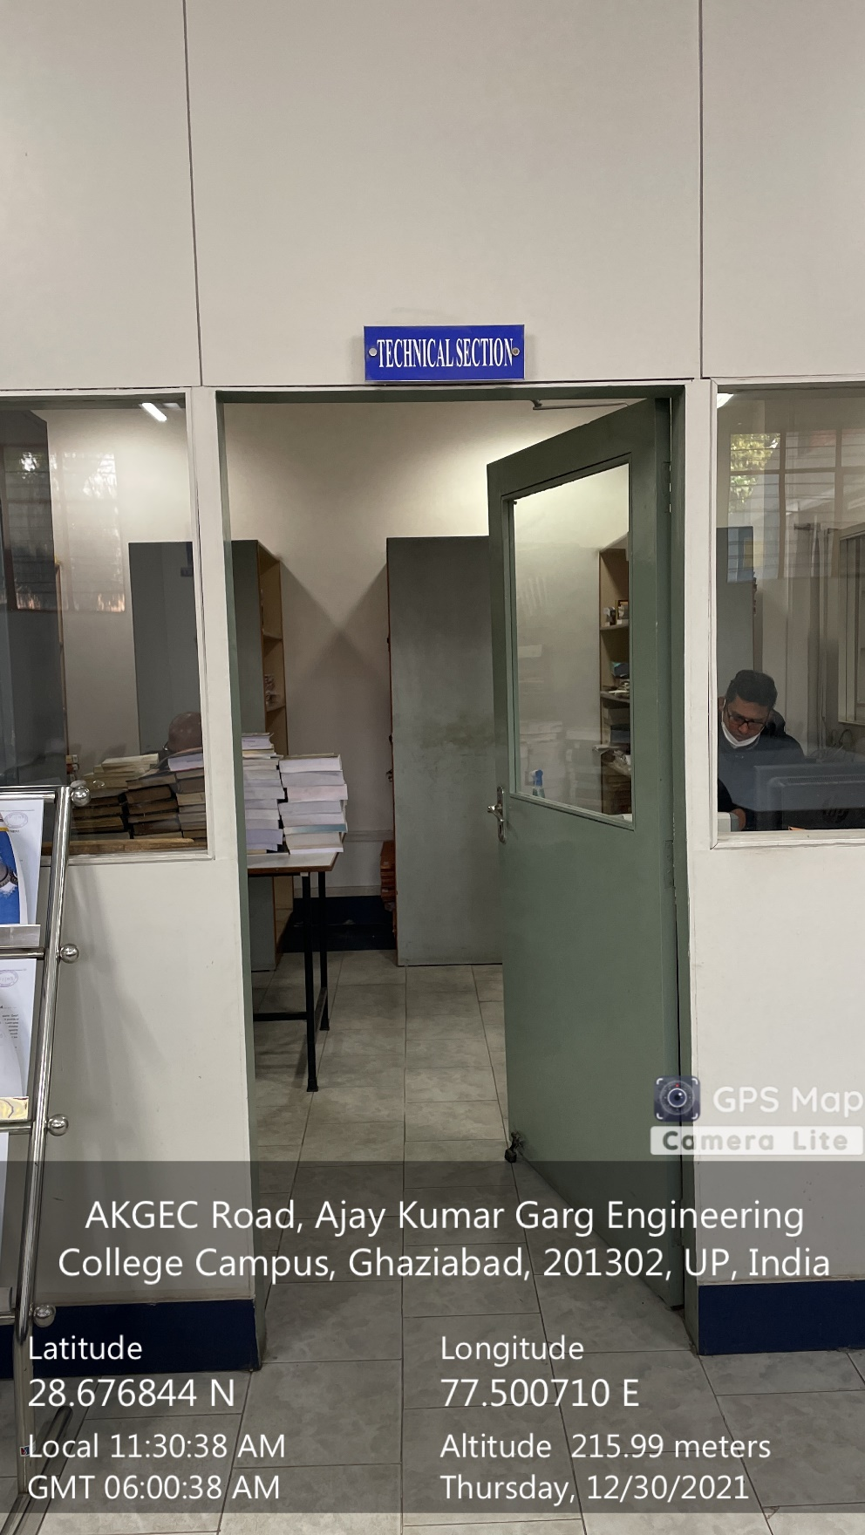

Technical Section

(ADMINISTRATE BLOCK, Ground Floor)

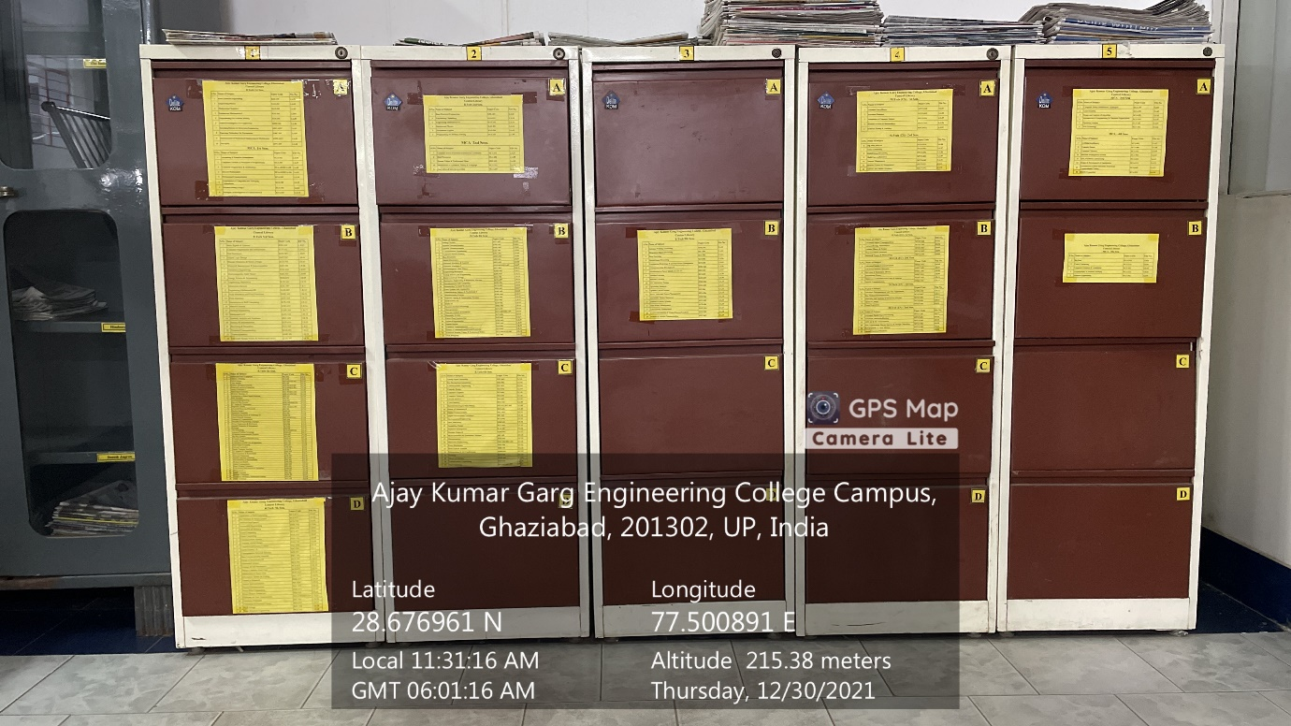

Question Bank

(ADMINISTRATE BLOCK, Ground Floor)

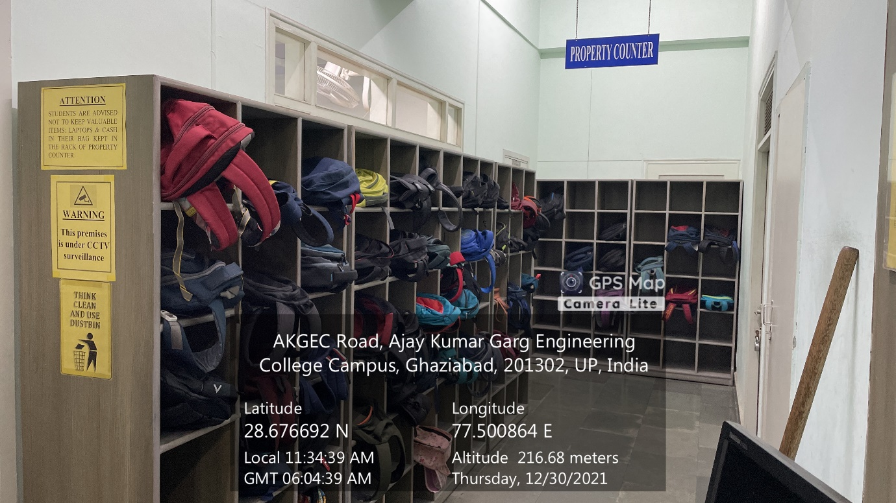

Property Counter

(ADMINISTRATE BLOCK, Ground Floor)

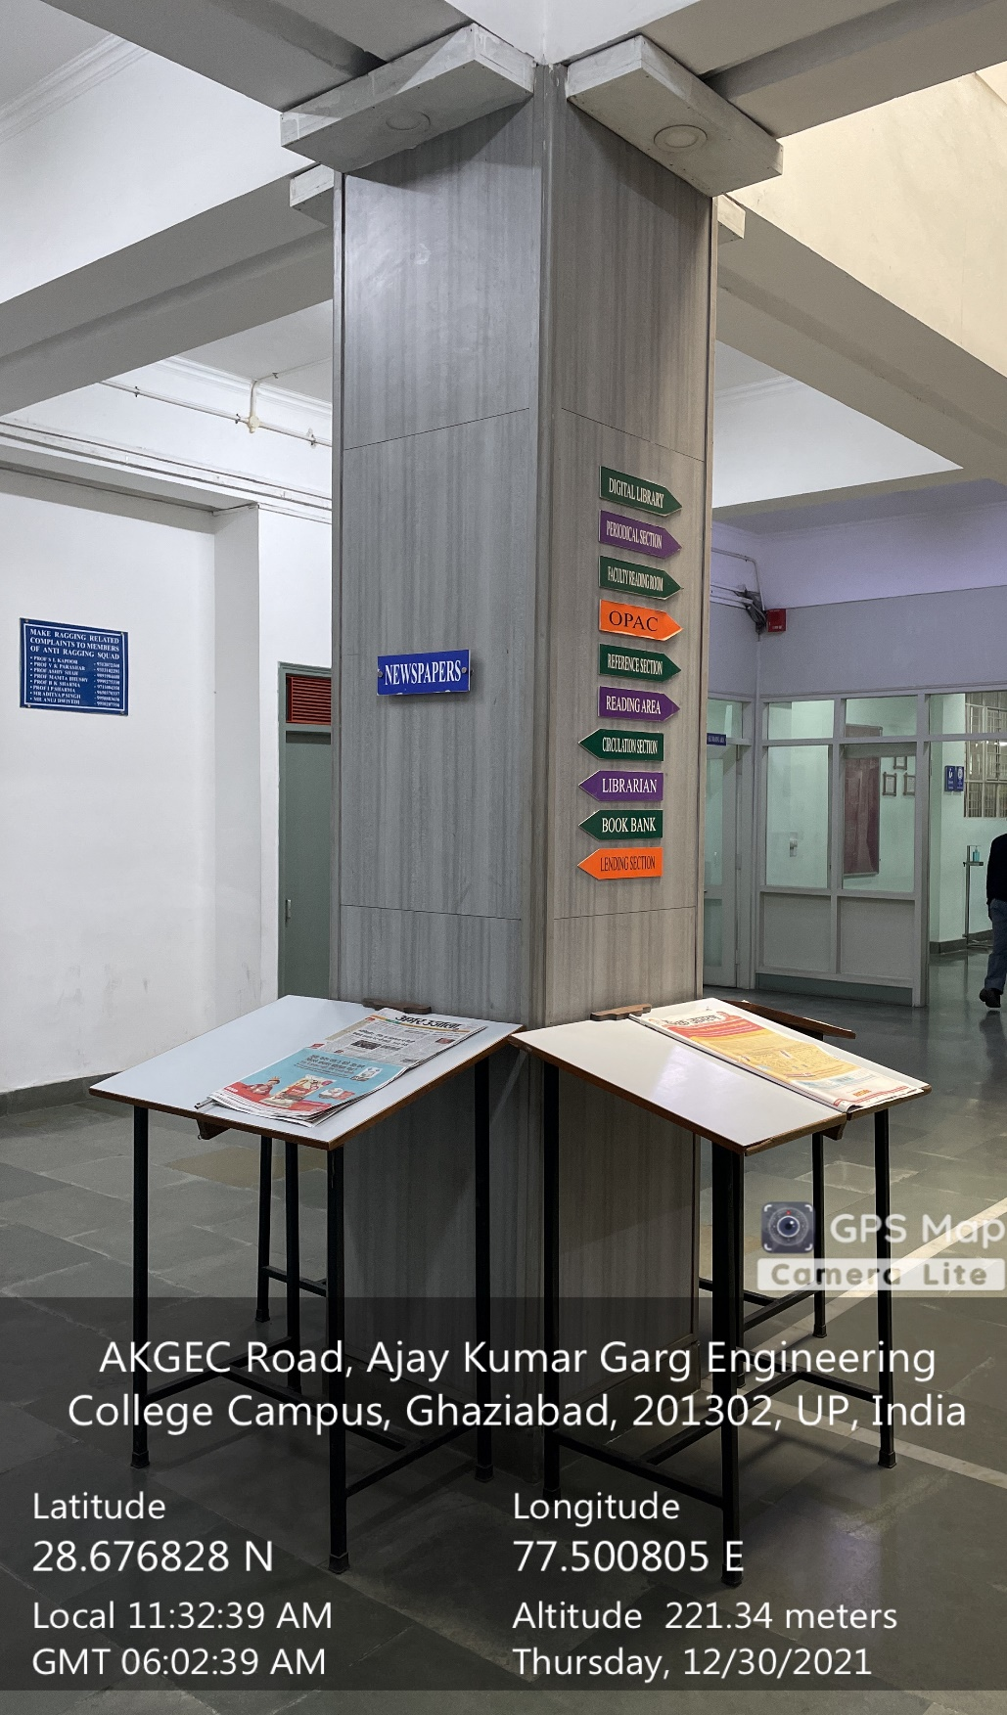

NewsPaper

(ADMINISTRATE BLOCK, Ground Floor)

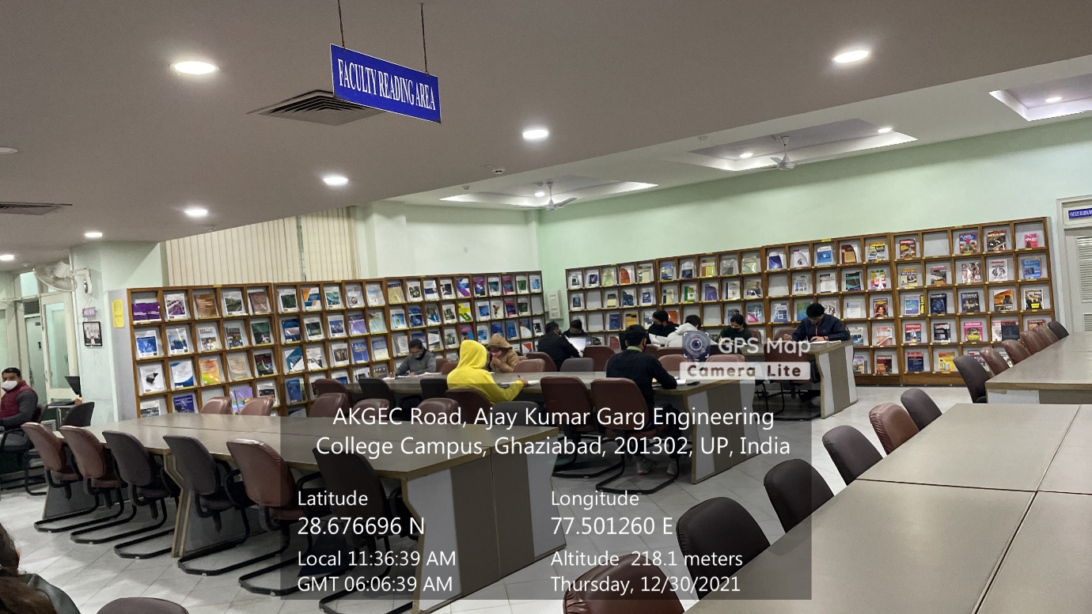

Magazine Counter

(ADMINISTRATE BLOCK, Ground Floor)

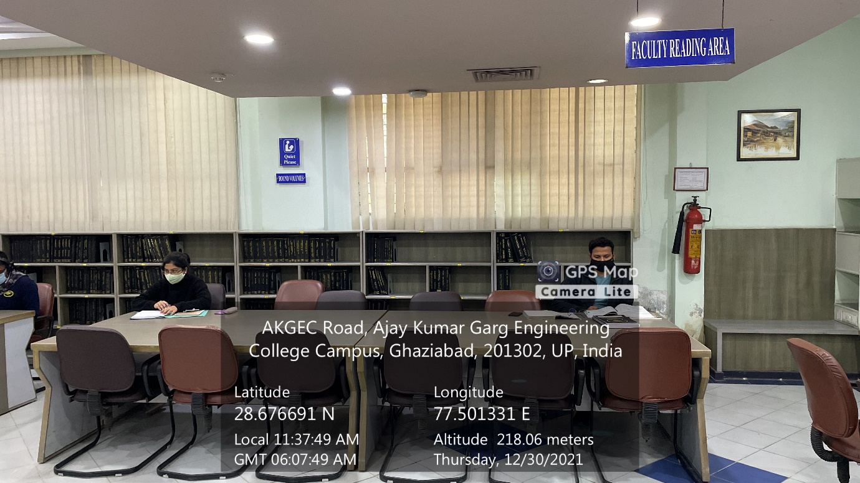

Faculty Reading Area

(ADMINISTRATE BLOCK, Ground Floor)

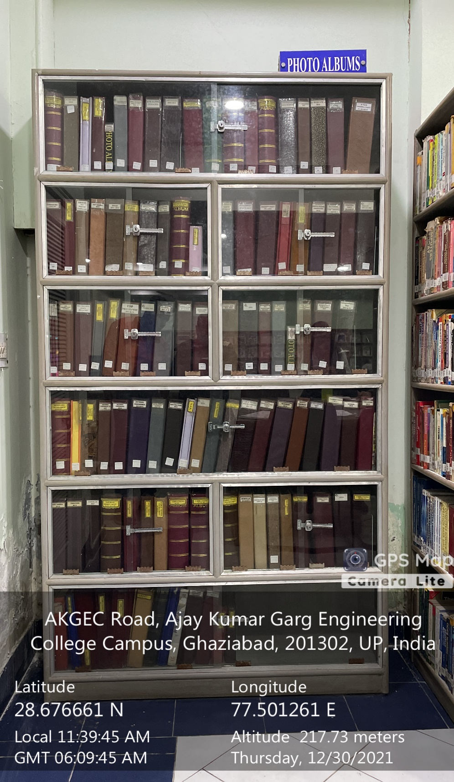

Photo Album

(ADMINISTRATE BLOCK, Ground Floor)

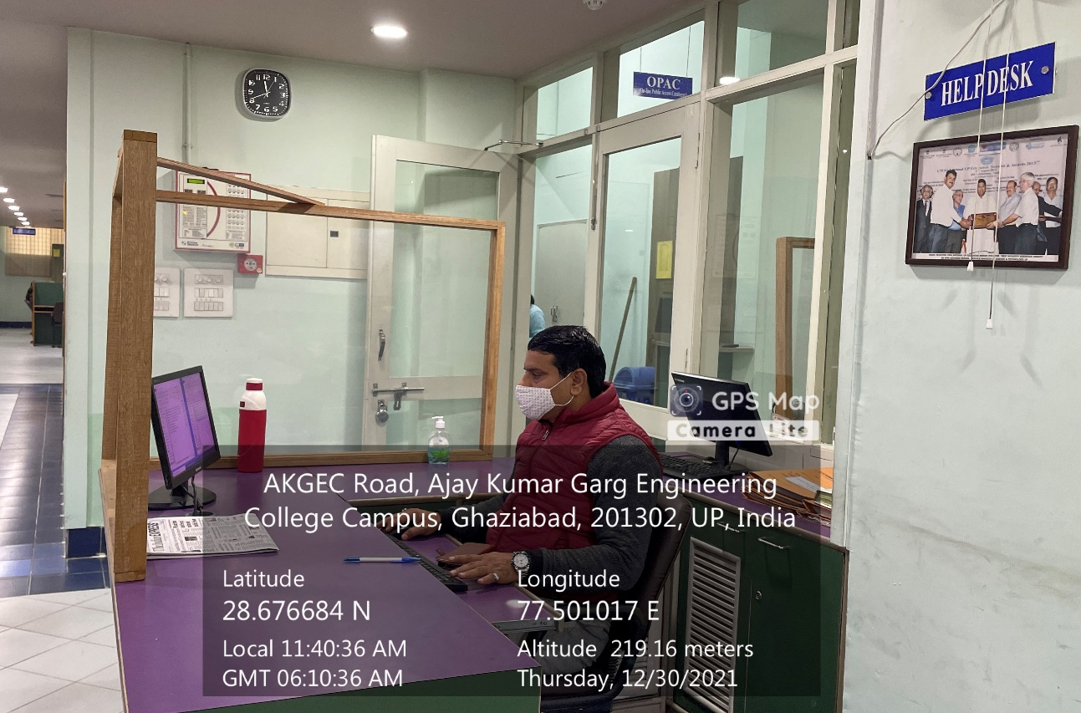

Helping Desk

(ADMINISTRATE BLOCK, Ground Floor)

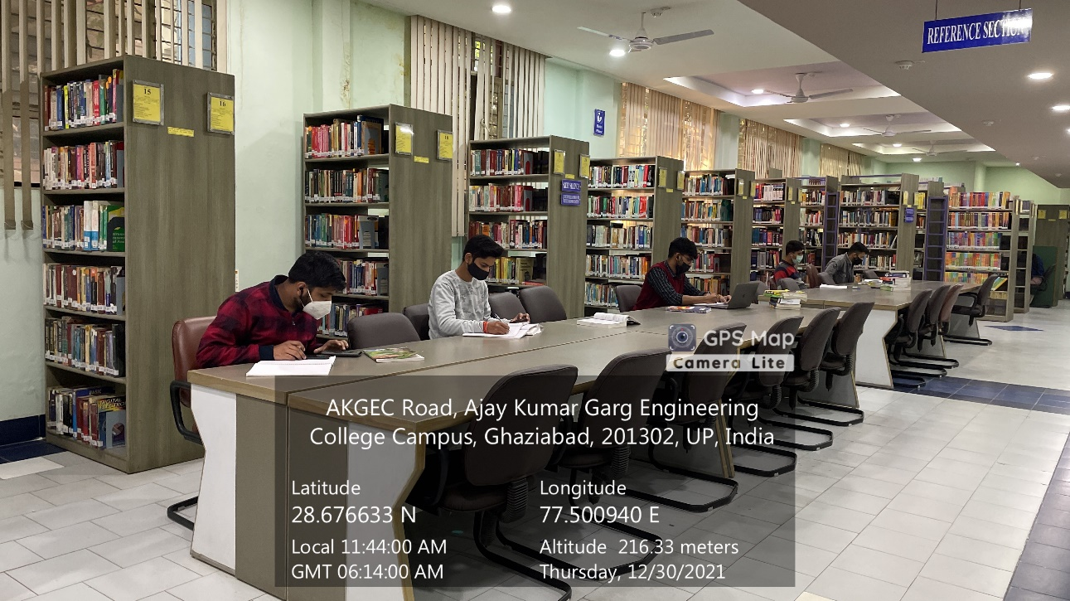

Reference Section

(ADMINISTRATE BLOCK, Ground Floor)

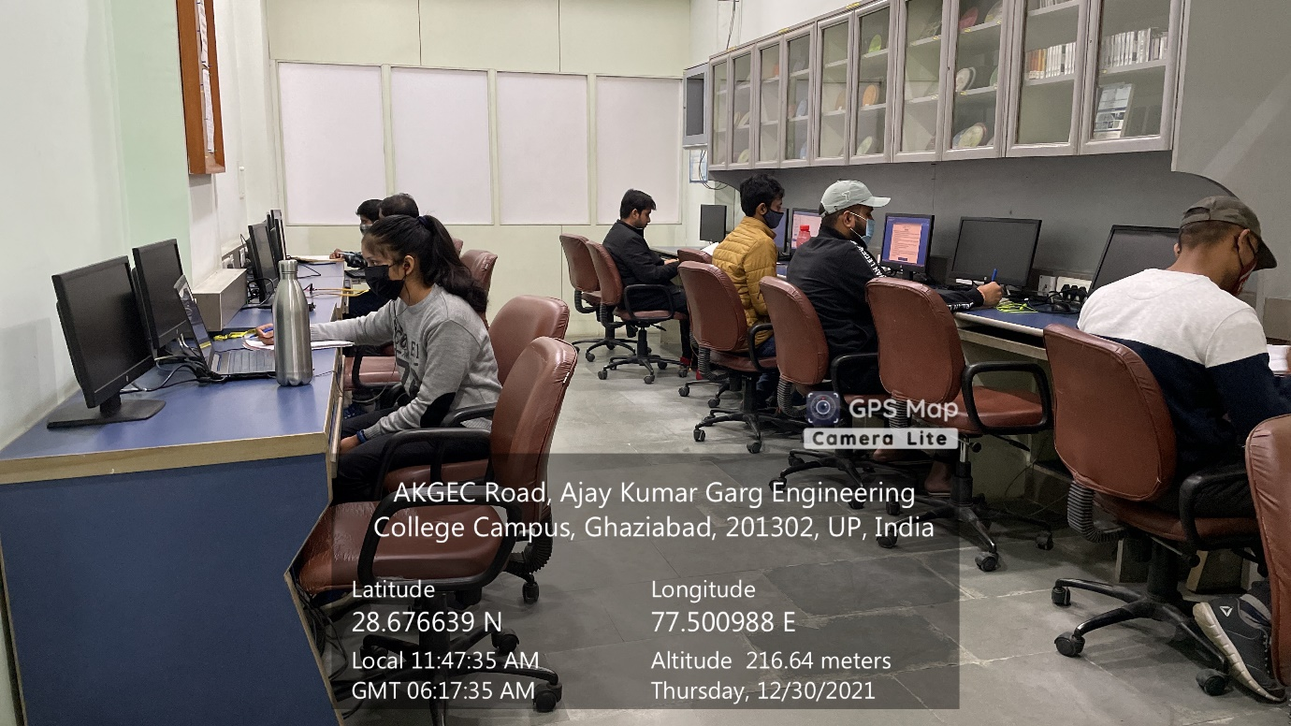

Digital Lab

(ADMINISTRATE BLOCK, Ground Floor)

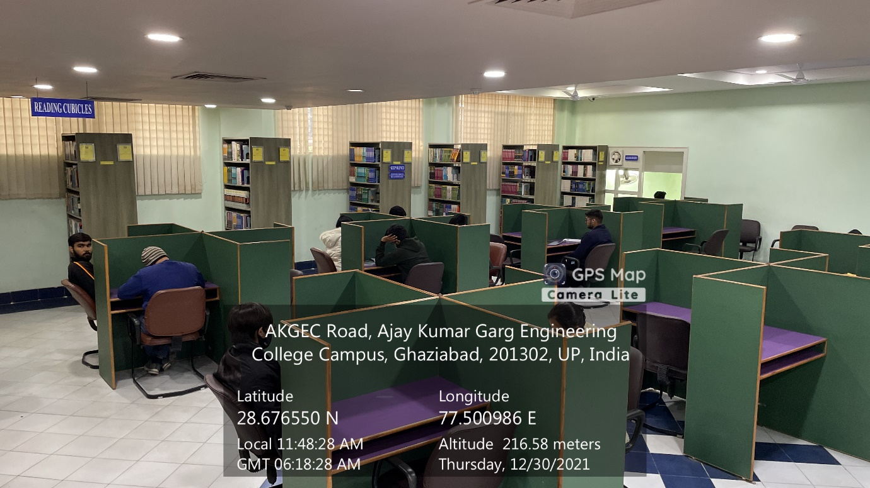

Reading Cubicles

(ADMINISTRATE BLOCK, Ground Floor)

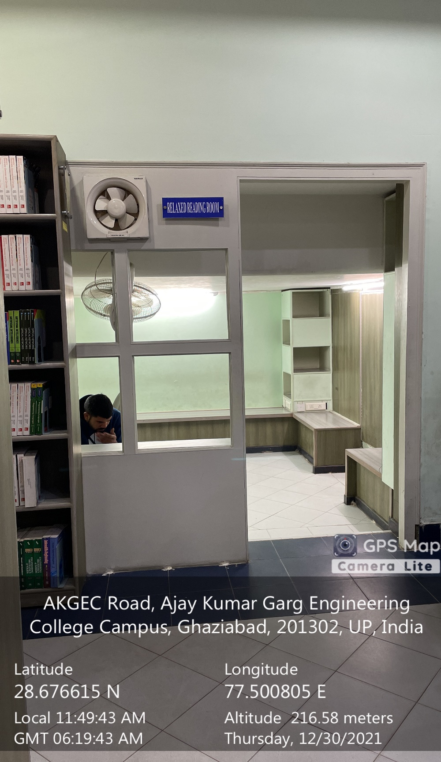

Relaxation Room

(ADMINISTRATE BLOCK, Ground Floor)

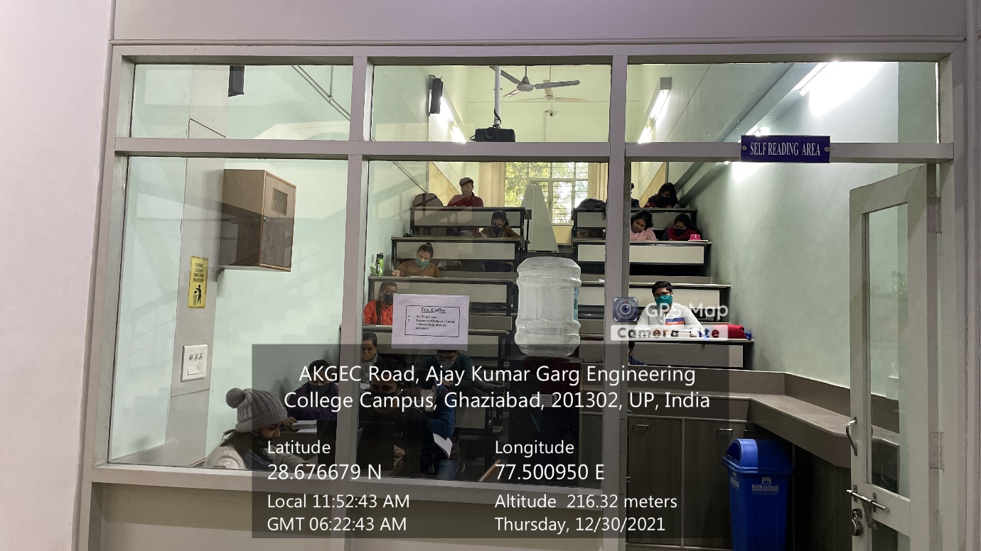

Self Reading Area

(ADMINISTRATE BLOCK, Ground Floor)

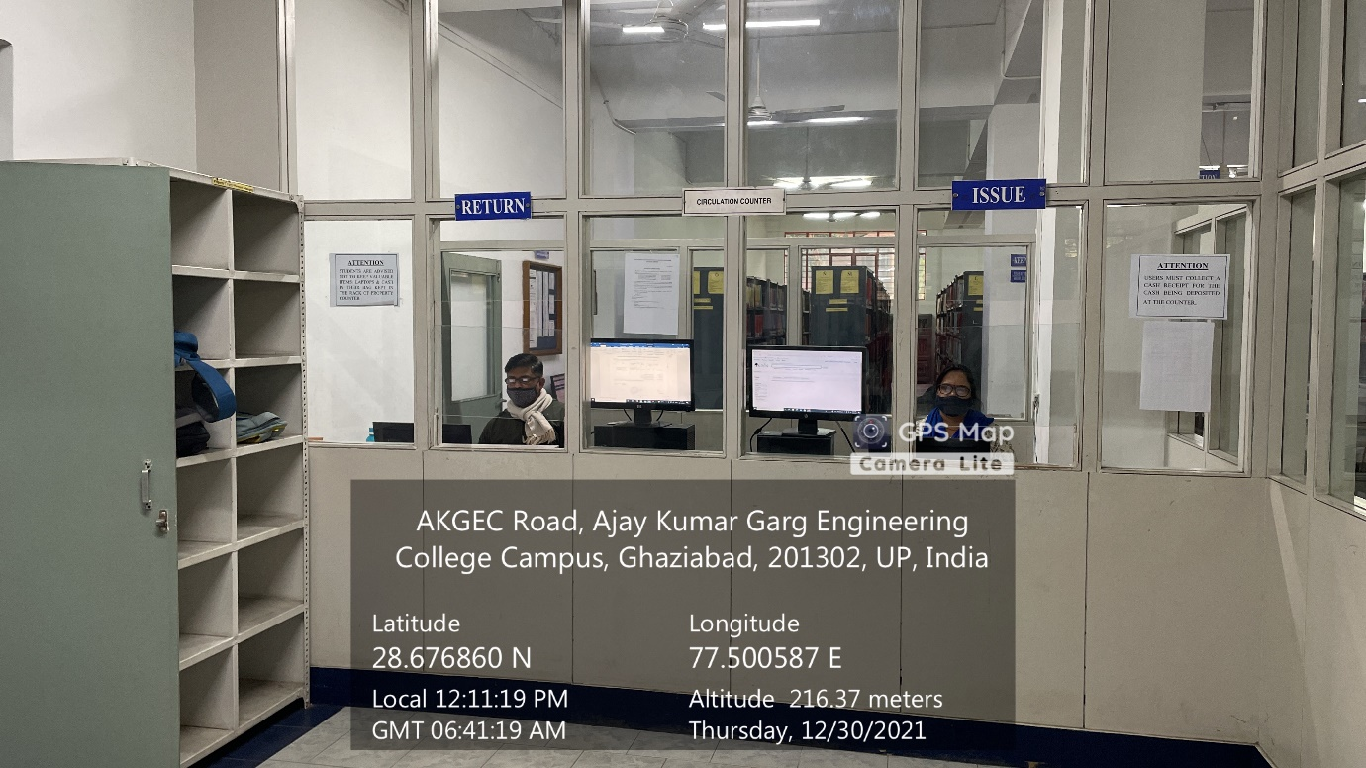

Book Issue/Return Counter

(ADMINISTRATE BLOCK, Ground Floor)

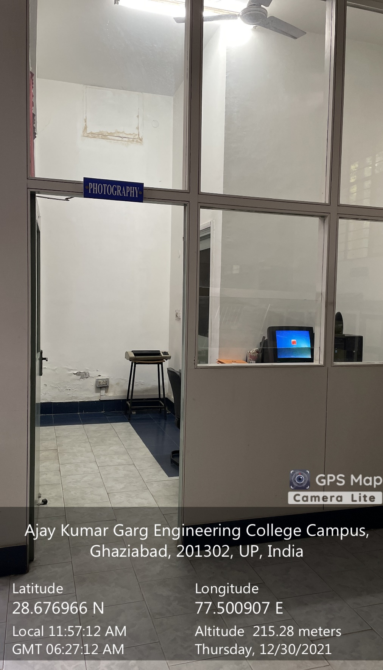

Photography Section

(ADMINISTRATE BLOCK, Ground Floor)

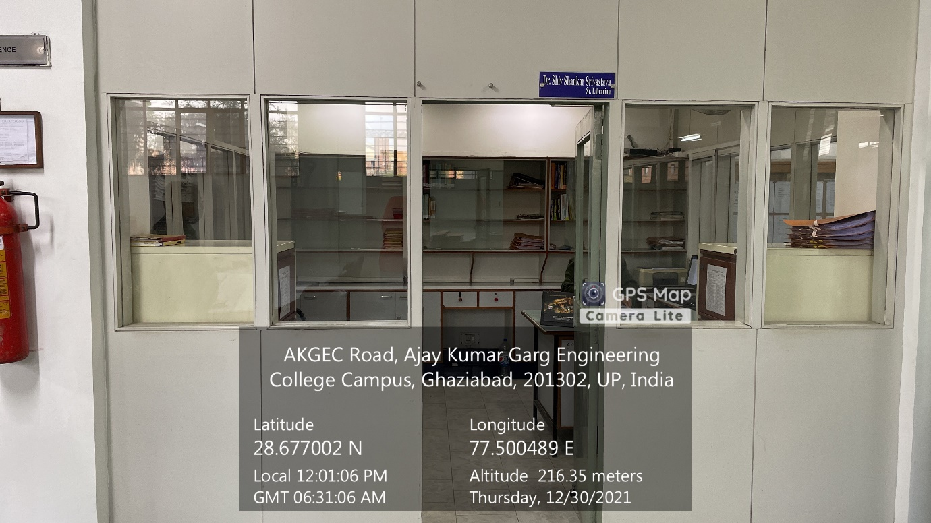

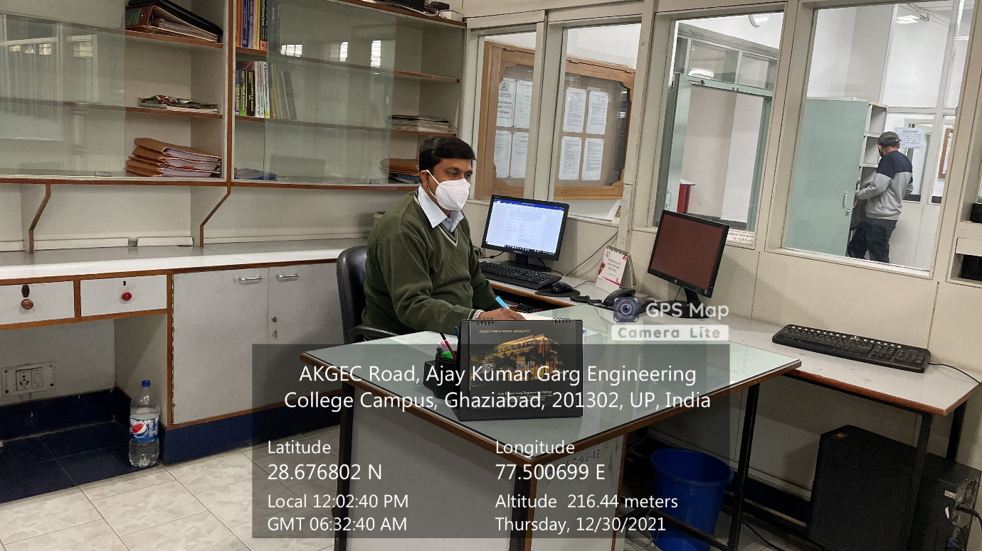

Sr. Librarian

(Dr. Shiv Shankar Srivastava)

(ADMINISTRATE BLOCK, Ground Floor)

***GIRLS HOSTAL LIBRARY***

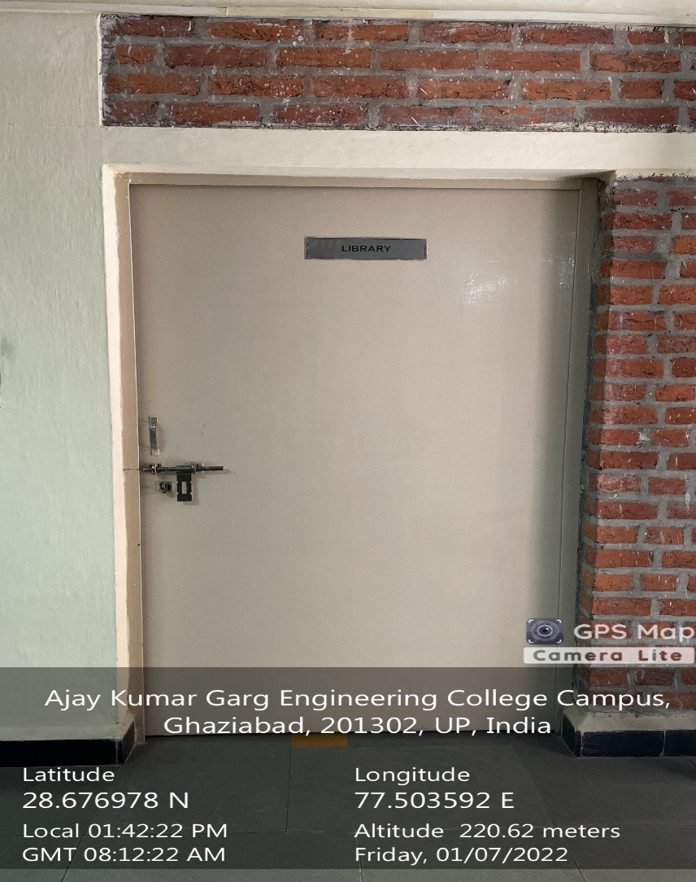

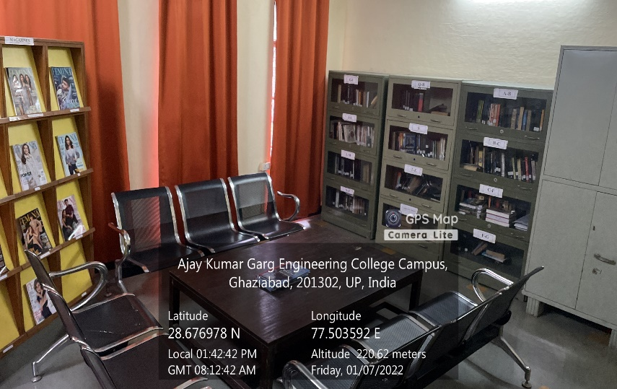

GH 1 Library

(Girls Hostel 1 , Second Floor)

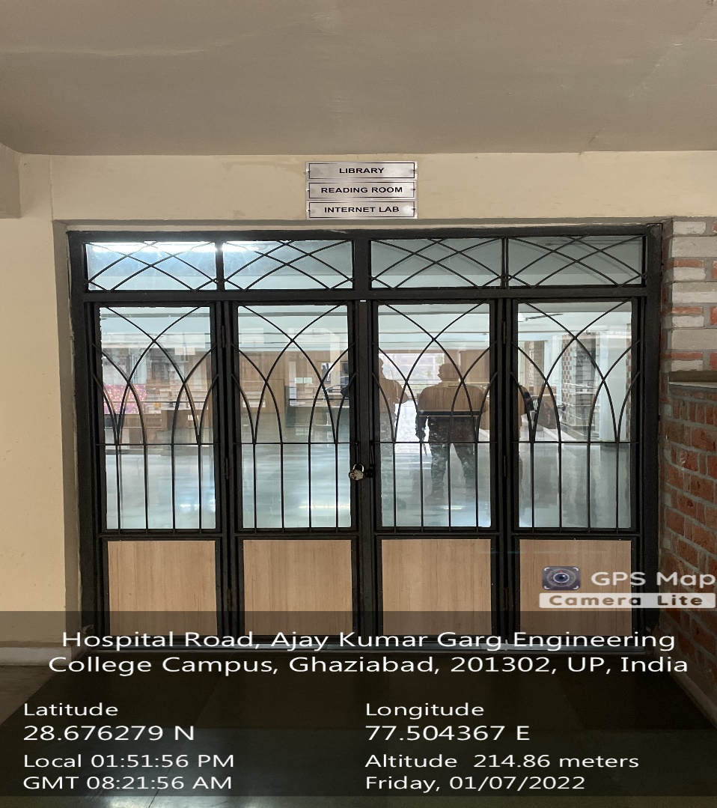

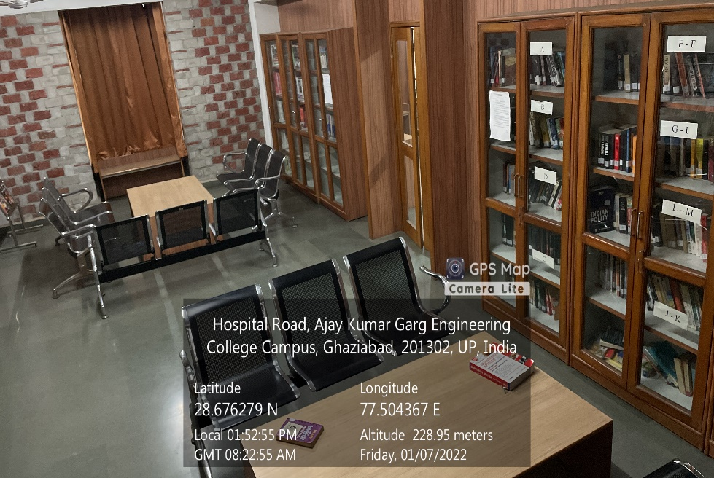

GH 2 Library

(Girls Hostel 2 , Third Floor)

***BOYS HOSTAL LIBRARY***

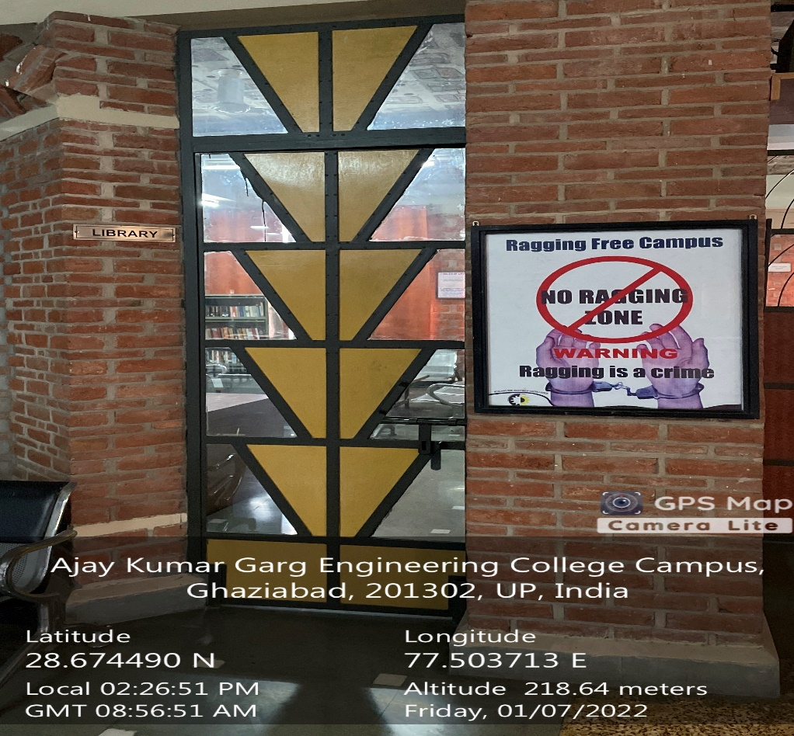

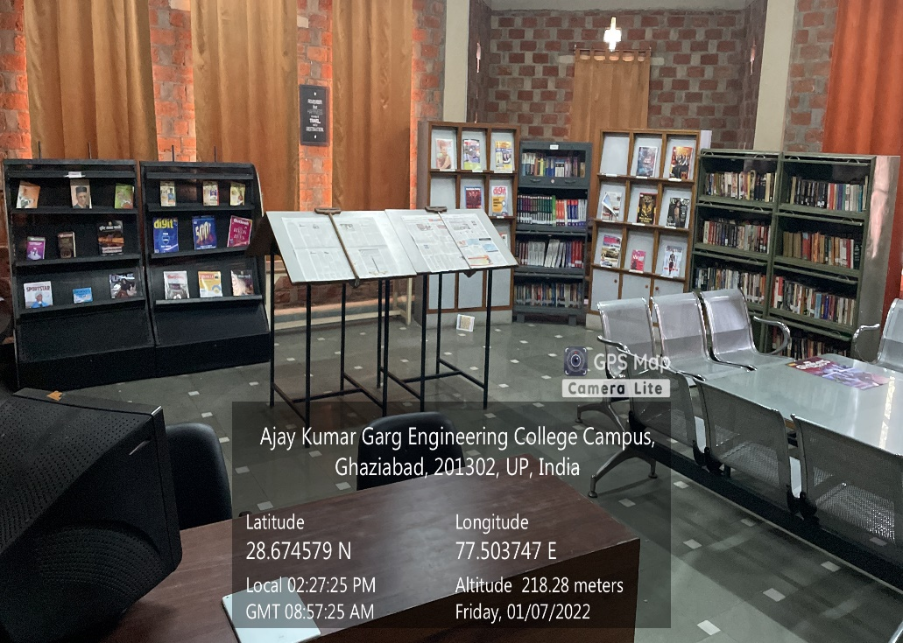

BH 1 Library

(Boys Hostel 1 , Second Floor)

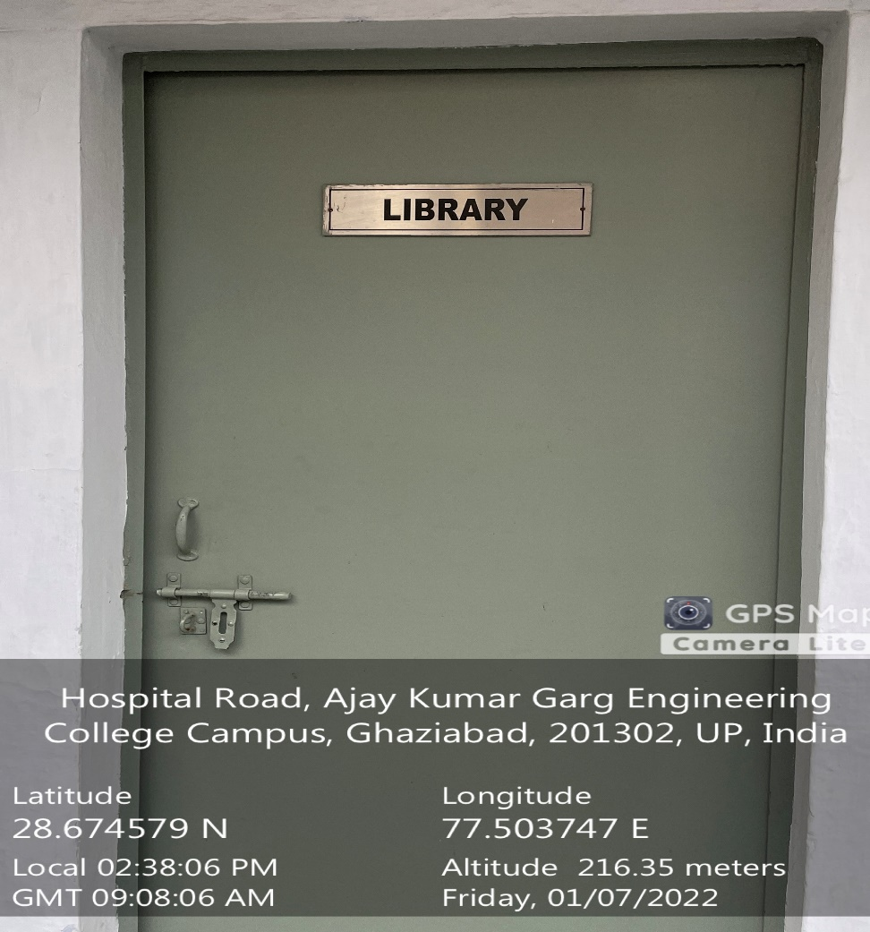

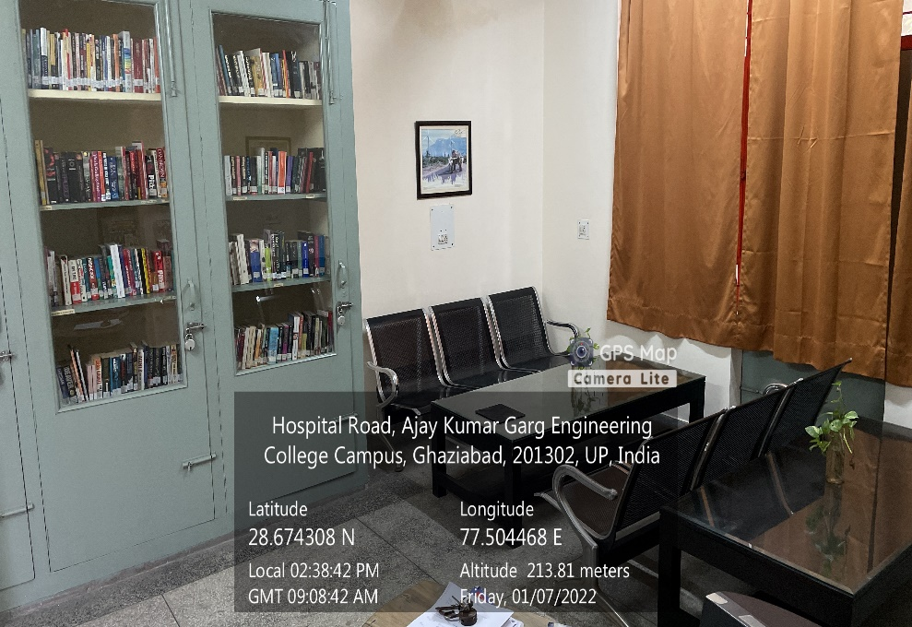

BH 2 Library

(Boys Hostel 2 , Second Floor)

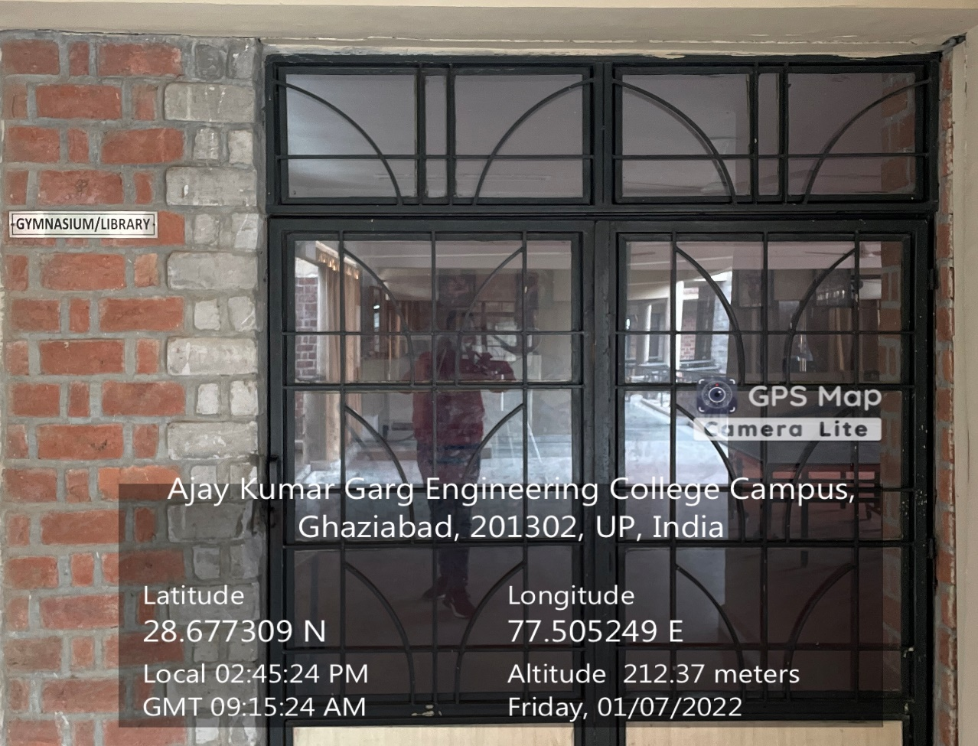

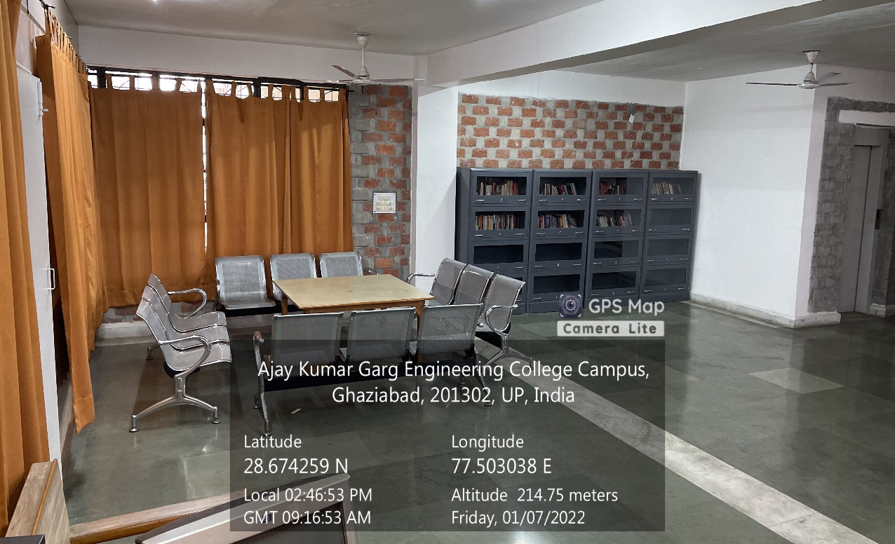

BH 3 Library

(Boys Hostel 3 , Second Floor)